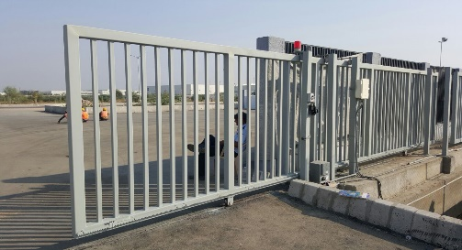
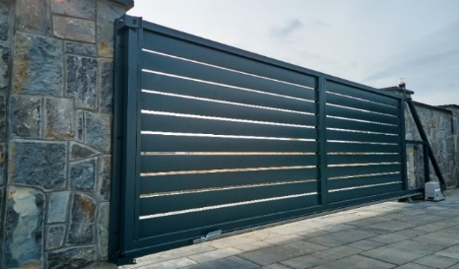
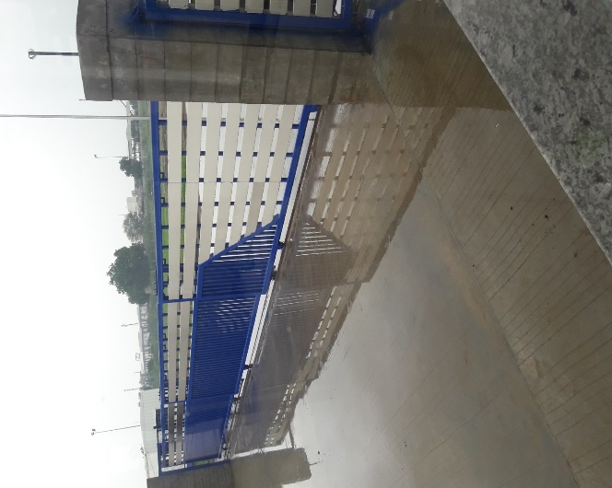
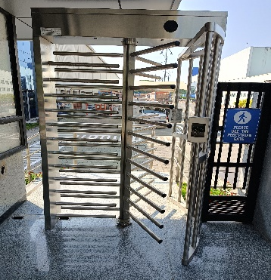
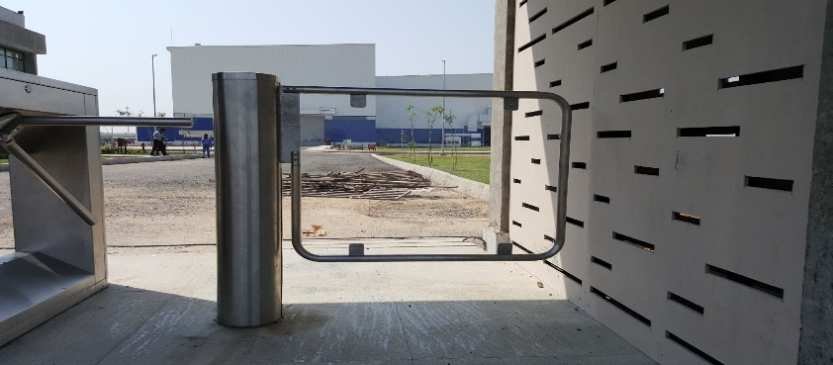
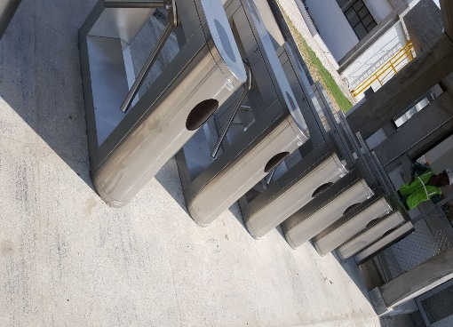
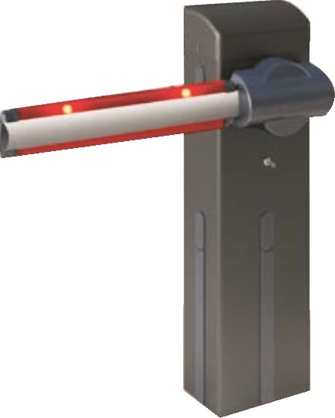
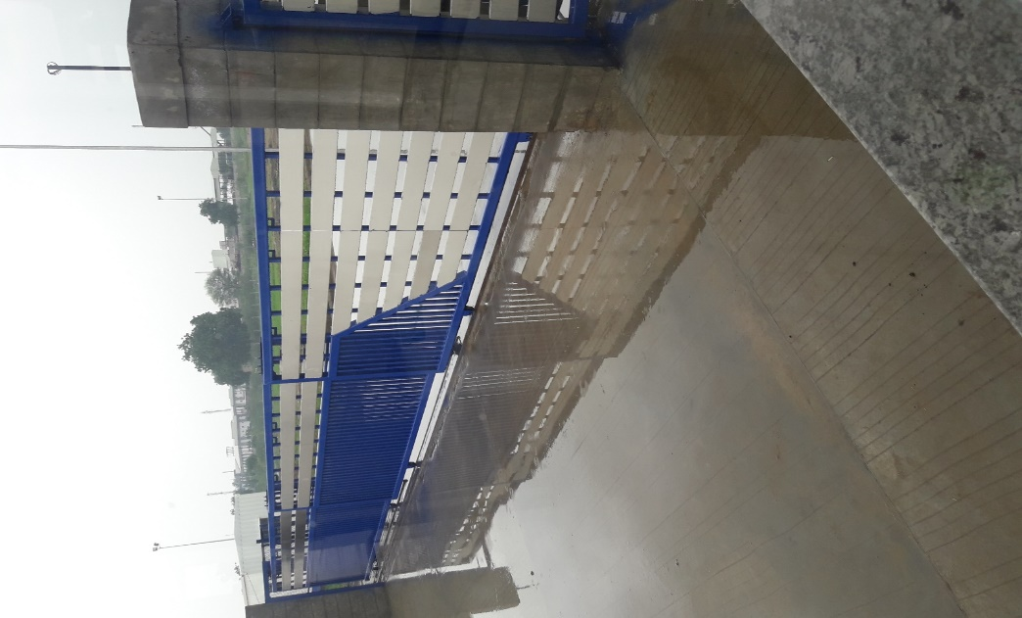
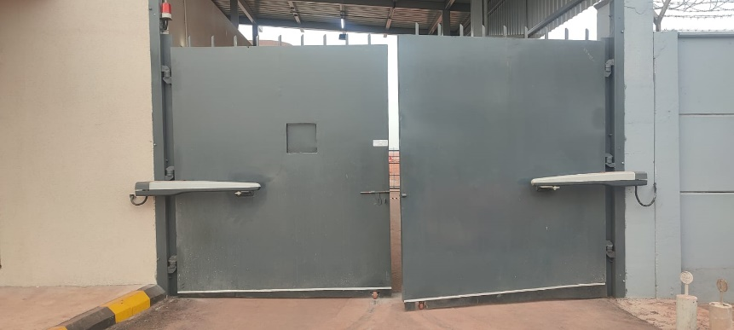
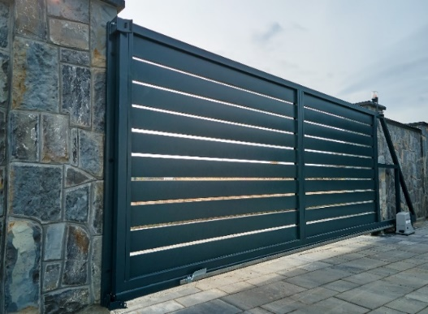

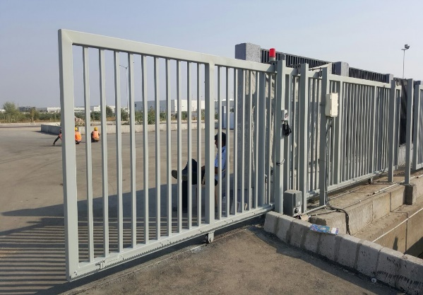
High Performance

ENTRANCE & ACCESS Control Devices….
AUTOMATION
Motorized Telescopic Gate
- Widely used where there is space constraints for sliding gate alongside the boundary wall or limited space for Run back.
- Telescopic gates manufactured in two or three gate leaves which makes possible to achieve Larger clear opening.
- Two or three bottom rails are required depending on clear width requirement.
- High precision sprocket & chain mechanism, guide rollers, bottom rollers, limit switch ensures smooth & safe operation of gate.
Motorized Sliding Gate
- Effortless operation with automated swinging action, providing convenient entry and exit with Wide opening (1000mm to 12000mm)
- Built with high-quality materials to withstand weather conditions and ensure long-lasting performance.
- Integrated sensors to detect obstructions and prevent the gate from closing, ensuring safety for pedestrians and vehicles.
- Convenient remote access options, allowing you to open and close the gate from the comfort of your vehicle or home.
- Wide range of design, finishes, and materials to match your personal taste and home's aesthetics.

Motorized Cantilever Gate
- Noise-free movement of gate.
- No Track or concrete foundation required on the roadway.
- Obstacle free entry without any bumps.
- No risk of non-functioning of gate due to bending or wearing-tearing of bottom rail.
- Can be easily installed on uneven or sloped ground surface.
- Imported monolithic cantilever track & pair of heavy duty bottom carriages.
Motorized Sliding Gate

- Motorized or manual drive system propels the gate along.
- Constructed from sturdy materials like steel or aluminium.
- Obstacle detection sensors prevent accidents by halting gate movement.
- Includes latch or electronic system for secure closure.
- Operated via control panel or remote transmitter for convenience.
- Length of gate can be fabricated from 1000mm - 15000mm.
- Can be fabricated for gates up to 18000 kg weights capacity.
- Bottom rail made up of polished bright bar supported with heavy duty beam.
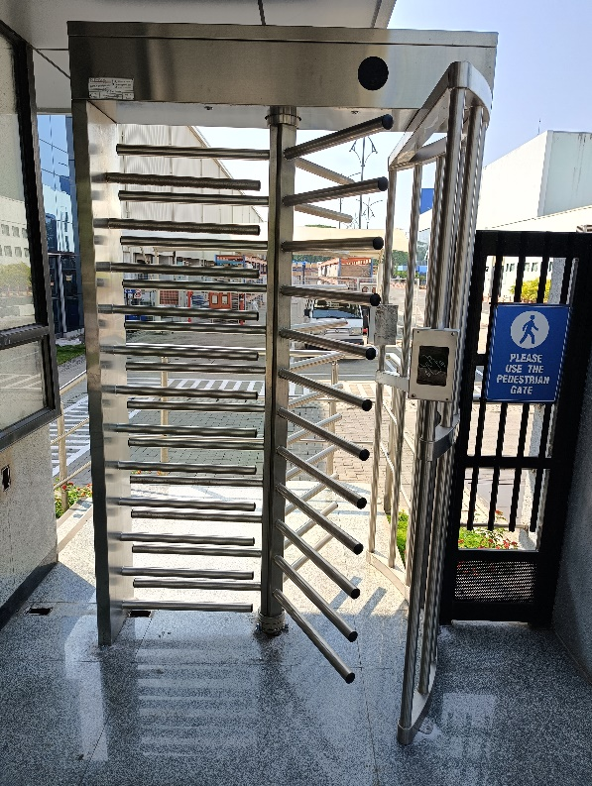
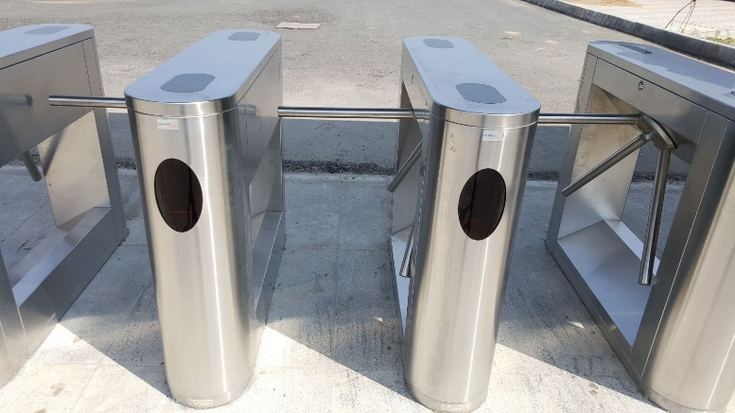
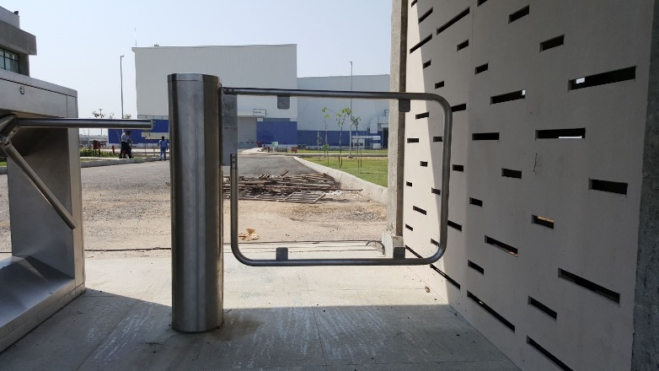
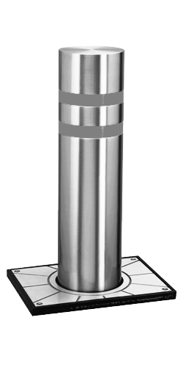
Turnstiles
Turnstile gate consisting of rotating arms or barriers that allow one person to pass at a time, commonly used for crowd control and access management. It serves as a security measure to regulate the flow of people in various settings such as stadiums, public transport stations, and office buildings. Turnstiles come in various types, including tripod, full-height, and waist-high, each offering different levels of security and throughput. Their primary function is to ensure authorized entry while deterring unauthorized access, making them an essential tool for maintaining security and order in high-traffic areas.
Bollards
Rising automatic hydraulic bollards provides secure solutions for vehicle access controls & traffic regulation where high level of security is required such as embassies, consulates, airports, hotels etc... It comes in 500mm height & 200mm diameter obstacle height. Rising & falling time is 4 seconds. Is suitable for intensive use application.
Boom Barrier
Boom barrier suitable for a range of larger openings from 1 — 1 2 meter and is ideal solution for toll collections, control of roads & parking areas for public places & industrial areas. Available for boom length up to 8 Metres. Opening up to 1 6 Meter can be covered with two barriers operating as master [slave it is available in blend design and modern technologies of illumination with in-built flashing light, round tubular bar and telescopic boom as well. All barriers are suitable for outdoor application with IP 54 protection class. Accessories such as photocell, loop sensor, flashing light, remote sensor, rack, mobile support articulation provision making it ideal for any application. Compact size and extremely smooth operation, reliable and maintenance free. Robust steel structure and its scratch proof coating
Sliding Gate
- Smooth Safe & economical operation.
- Varied lengths of gates can be fabricated from 1000mm - 12000mm.
- Can be fabricated for gates up to 18000 kgs weights capacity.
- Bottom rail made up of polished bright bar supported with heavy duty beam.
- Bottom roller with high precision bearings
Sliding Gate
- Smooth Safe & economical operation.
- Varied lengths of gates can be fabricated from 1000mm - 12000mm.
- Can be fabricated for gates up to 18000 kgs weights capacity.
- Bottom rail made up of polished bright bar supported with heavy duty beam.
- Bottom roller with high precision bearings
Sliding Gate
- Smooth Safe & economical operation.
- Varied lengths of gates can be fabricated from 1000mm - 12000mm.
- Can be fabricated for gates up to 18000 kgs weights capacity.
- Bottom rail made up of polished bright bar supported with heavy duty beam.
- Bottom roller with high precision bearings
Sliding Gate
- Smooth Safe & economical operation.
- Varied lengths of gates can be fabricated from 1000mm - 12000mm.
- Can be fabricated for gates up to 18000 kgs weights capacity.
- Bottom rail made up of polished bright bar supported with heavy duty beam.
- Bottom roller with high precision bearings
Sliding Gate
- Smooth Safe & economical operation.
- Varied lengths of gates can be fabricated from 1000mm - 12000mm.
- Can be fabricated for gates up to 18000 kgs weights capacity.
- Bottom rail made up of polished bright bar supported with heavy duty beam.
- Bottom roller with high precision bearings
Head Office: 187, G-Block, 1st Floor, Thermax Chowk,
MIDC, Above Kotak and Saraswat Bank,
Chinchwad, Pune - 411019
NIHVA

TECHNOLOGIES
PVT. LTD.
hhghhhffgfgfg













Installation
Warranty
Annual
Inspection
Preventive
Maintenance
Repairs
Modernization
Equipment
Survey
Replacement
NIHVA
Customer
Maintenance &
Modernization
Automatically
Green
sales@nihva.com
+91 2066 3040 33
+91 8551 0913 33
www.nihva.com
www.shivaah.com
Contact

